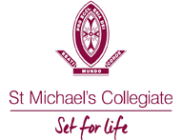

COVID-19 SAFETY PLAN - Basketball

St Michael’s Collegiate

School | St Michaels Collegiate
School Location | 218 Macquarie Street, Hobart, 7000
Sport | Basketball
Sport Facility Type and Location | Basketball Gym  218 Macquarie Street, Hobart, 7000
Principal | Dr Adam Forsyth
Contact Email | Adam.forsythe@collegiate.tas.edu.au
Contact Number | (03) 6211 4910
School COVID Officer for Sport | Jessica Blake
Contact Email | Jessica.blake@collegiate.tas.edu.au
Contact Mobile Number | 0431 105 862
Version | 2
Plan Last Updated | 02/07/2020
Plan Prepared by – Jessica Blake

Template Instructions
- The Australian Institute of Sport (AIS) has published a “Framework for Rebooting Sport in a COVID-19 Environment” to inform the resumption of sporting activity in Australia, including community sport. Sport Australia has separately developed a “Return to Sport Checklist for Clubs and Associations” that provides operational guidance to local sporting clubs and associations on considerations that should be taken into account to appropriately resume sport and club operations.
- To support the AIS and Sport Australia return to sport documents, Sport Australia has developed this COVID-19 Safety Plan template. This template can be used by associations and clubs to consolidate their planning for the resumption of activities at its club. Your association/club should review the Sport Australia Checklist and document its operational requirements for return to sport in the Appendix to this COVID-19 Safety Plan.
- Yellow highlighting within brackets i.e. [ ] indicates further information is required from an association/club prior to finalising and adopting the COVID-19 Safety Plan. Before finalising, insert relevant information where highlighted in yellow and delete these template instructions.
- Your association/club’s COVID-19 Safety Plan should be appropriately ratified within your club’s governance arrangements and regularly reviewed to ensure it remains fit for purpose and aligned with the AIS Framework, government restricted activity measures, public health advice and health and safety laws.
- DISCLAIMER: This template does not constitute legal or health and safety advice. A club should take its own professional advice regarding the development and contents of its COVID-19 Safety Plan.

Table of Contents
Template Instructions Error! Bookmark not defined.
1. Introduction Error! Bookmark not defined.
2. Key Principles Error! Bookmark not defined.
3. Responsibilities under this Plan Error! Bookmark not defined.
4. Return to Sport Arrangements Error! Bookmark not defined.
4.1 AIS Framework Arrangements 5
4.2 Roadmap to a COVIDSafe Australia 6
5. Recovery Error! Bookmark not defined.
Appendix: Outline of Return to Sport Arrangements Error! Bookmark not defined.
Part 1 – Sport Operations 7
SPORT: Basketball 7
Part 2 – Facility Operations Error! Bookmark not defined.
FACILITY NAME: Collegiate Gym 9
Type of facility (indoor/outdoor): Indoor……………………………………………………………...…………………………..9
Appendix A – Basketball Protocols …………………………………………………………………………………………….12
Appendix B – Attendance Register…………………………………………………………….……………………………….13
Appendix C – Meeting Point Poster…………………………………………………………………………………………….14
Appendix D – Supervising Teacher Checklist…………………………………………………………………………………15

- Introduction
The purpose of this COVID-19 Safety Plan (Plan) is to provide an overarching plan for the implementation and management of procedures by St Michael’s Collegiate to support SATIS, SSATIS JSSATIS BASKETBALL and its members and participants in the staged resumption of inter-school sport and club activities.
The arrangements set out in this Plan are intended to prevent the transmission of COVID-19 among members, participants, coaches, officials, administrators/volunteers, visitors, families and the broader community. The Plan provides the framework to govern the general operation of SATIS/SSATIS/JSSATIS BASKETBALL, any facilities it controls, the playing/training behaviour of all members and participants and the monitoring and reporting of the health of attendees at St Michael’s Collegiate School facilities.
This Plan includes, but is not limited to, the conduct of:
  - staged training and competition activities (sport operations); and
  - facility management and supporting operations (facility operations).
At all times the Plan is subject to all regulations, guidelines and directions of government and public health authorities.
- Key Principles
This Plan is based on, and accepts, the AIS Framework for Rebooting Sport in a COVID-19 Environment (AIS Framework) and the National Principles for the Resumption of Sport and Recreation Activities (National Principles).
The Plan also accepts as key principles that:
- The health and safety of members, participants, coaches, officials, administrators/volunteers, visitors, families and the broader community is the number one priority;
- Members, participants, coaches, officials, administrators/volunteers, families and the broader community need to be engaged and briefed on St Michael’s Collegiate’s return to sport plans;
- Facilities are assessed and appropriate plans are developed to accommodate upgraded hygiene protocols, physical distancing and other measures to mitigate the risk of transmission of COVID-19;
- Training cannot resume until the arrangements for sport operations and facility operations are finalised and approved, if necessary; and
- At every stage of the return to sport process St Michael’s Collegiate must consider and apply all applicable State and Territory Government and local restrictions and regulations. St Michael’s Collegiate needs to be prepared for any localised outbreak at our facilities, within our competitions or in the local community.

- Responsibilities under this Plan
St Michael’s Collegiate retains the overall responsibility for the effective management and implementation of the return to sport activities and operations outlined in this Plan.
The Leadership team of St Michael’s Collegiate is responsible for:
- Approving the Plan and overseeing the implementation of the arrangements in the Plan; and
- Revising the Plan as required, ensuring it reflects up to date information from government and public health officials.
The Leadership team of St Michael’s Collegiate has appointed the following person as the St Michael’s Collegiate COVID-19 Safety Coordinator to execute the delivery of the Plan and to act as a point of contact for information relating to this Plan:
Name | Jessica Blake
Contact Email | sports@collegiate.tas.edu.au
Contact Number | (03) 6211 4918 or 0431 105 862
St. Michael’s Collegiate expects all members, participants, coaches, officials, administrative staff and volunteers to:
- Comply with the health directions of government and public health authorities as issued from time to time;
- Understand and act in accordance with this Plan as amended from time to time;
- Comply with any testing and precautionary measures implemented by St Michael’s Collegiate;
- Act with honesty and integrity in regard to the state of their personal health and any potential symptoms; and
- Monitor their health and take a cautious approach to self-isolation and reporting of potential symptoms.
- Return to Sport Arrangements
As from 26 June, The Plan outlines specific sport requirements that St Michael’s Collegiate will implement for Level C of the AIS Framework.
St Michael’s Collegiate will transition to the training activity and facility use as outlined in Level C of the AIS Framework Arrangements.
The protocols for conducting sport operations and facility operations under Level C of the AIS Framework are set out in the Appendix.
A checklist for Small Sporting Organisations as produced by Australian Sports Commission will be completed each week before Term 3 to check all protocols have been planned correctly.
  - AIS Framework Arrangements
The protocols for conducting sport operations and facility operations under Level B and Level C of the AIS Framework are set out in the Appendix.

  - Roadmap to a COVIDSafe Australia
St. Michael’s Collegiate will also comply with the Australian government’s Roadmap to a COVIDSafe Australia, which places limits on the type of activity that can be conducted and the number of people who can gather at facilities, notwithstanding the activities permitted by the AIS Framework (see below).
AIS Activities | Level A:  Training in no more than pairs. Physical distancing required. | Level B:  Indoor/outdoor activity. Training in small groups up to 10. Physical distancing required. |  | Level C:  Full sporting activity (training and competition) allowed. No restriction on numbers. Contact allowed.
Roadmap Activities | N/A | Step 1:  No indoor activity. Outdoor sport (up to 10 people) consistent with AIS Framework. | Step 2:  Indoor/outdoor sport up to 20 people. Physical distancing (deNotnsity 4m²). | Step 3:  Venues allowed to operate with up to 100 people with physical distancing. Community sport expansion to be considered consistent with AIS Framework. | Further steps  Be aware of Tasmanian state government updates on COVID protocols and apply these to the current safety plans. Now 250 people in indoor areas with a 2m² density.
- Recovery
When public health officials determine that the outbreak has ended in the local community, St Michael’s Collegiate will consult with relevant authorities to identify criteria for scaling back its COVID-19 prevention actions. St Michael’s Collegiate will also consider which protocols can remain to optimise good public and participant health.
At this time the Leadership team of St Michael’s Collegiate will consult with key stakeholders to review the delivery of its return to sport arrangements and use feedback to improve organisational plans and systems.

Appendix: Outline of Return to Sport Arrangements for start of Term 3 2020
Note – this Plan is for Basketball played in the Collegiate Gym, Appendix A – Basketball Gym Poster; Appendix B – Meeting place Poster; Appendix C - St Michael’s Collegiate Attendance Register.

Part 1 – Sport Operations
  - Sport: Basketball
Area | Plan Requirements (for activities under AIS Framework Level B) | Plan Requirements (for activities under AIS Framework Level C)
Approvals | The school must obtain the following approvals to allow a return to training at Level B:  - State Government approval of the resumption of community sport.  - Relaxation of public gathering restrictions to enable training to occur.  - Local government/venue owner approval to training at venue, if required.  - National/state sporting body/local association approval of return to training for community sport.  - Club committee has approved return to training for club.  - Insurance arrangements confirmed to cover training. | The school must obtain the following approvals to allow a return to training/competition at Level C:  - Relaxation of public gathering restrictions to enable training to occur.  - Local government and St. Michael’s Collegiate (venue owner) given approval for training/competition at Ham Common  - National, state sporting body and SATIS approval to return to training/competition for community sport.  - SATIS committee has approved return to competition for St. Michael’s Collegiate.  - Insurance arrangements confirmed to cover competition.
Training Processes | - St. Michael’s Collegiate to emphasise AIS Framework principle of “Get in, train, get out” – arrive ready to train.  - Length and scheduling of training sessions to reduce overlap.  - Small group sessions, with no physical contact  - Personal hygiene enforced – hand sanitiser before and after play.  - All used equipment must be taken to designated bucket where it will be sanitised after each training/game;  - Players’ bibs must be placed in designated bucket where they will be washed after each training/game;  - No sharing of personal equipment.  - Students to take walk to gym and meet coach there, no lingering in the foyer area, please go into the gym directly  - Training attendance register kept by Manager and submitted to Sports department after each training. | - AIS Framework principles – full sporting activity that can be conducted in groups of any size (subject to COVIDSafe Roadmap) including full contact.  - Full contact under Level C AIS guidelines and Tasmanian State government is allowed;  - Limit unnecessary physical interactions; No Spectators will be allowed into the St. Michael’s Collegiate Gym.  - No Spectators will be allowed to enter into the building/foyer of the Gym.  - Only coaches, managers, officials and COVID Safe Officer are allowed in Gym with players;  - Clearly outline nature of training permitted.  - All used equipment must be taken to designated bucket where it will be sanitised after each training/game;  - Players’ bibs must be placed in designated bucket where they will be sanitised or taken home and washed after each training/game;  - Personal hygiene enforced – washing hands; hand sanitiser before entry;  - No sharing food or equipment
Personal health | - Graded return to sport to avoid injury.  - Advice to players, coaches, volunteers to not attend if unwell (including any signs/symptoms of cold, flu, COVID-19 or other illness).  - Each player to wash hands and use sanitiser before entering facility.  - Avoid physical greetings (i.e. hand shaking, high fives etc.).  - All players to use good hygiene if coughing or sneezing.  - Launder own training uniform and wash personal equipment  - No change rooms to be used on site  - Toilet facilities available for players and officials only  - No sharing of food at any time, players to bring own food and sanitise hands after eating.  - When using a mouthguard avoid taking it in and out. If touched must sanitise hands. | - Advice to players, coaches, volunteers to not attend if unwell (including any signs/symptoms of cold, flu, COVID-19 or other illness).  - Each player to wash hands and use sanitiser before entering facility.  - Each player to place bib in designated bucket after each training/game for cleaning.  - All players to use good hygiene if coughing or sneezing.  - All players to use their own water bottles – no sharing.  - Changing rooms not available on site  - No sharing of food at any time, players to bring own food and sanitise hands after eating.  - When using a mouthguard avoid taking it in and out. If touched must sanitise hands.
Hygiene | - Manager is responsible for spraying all benches used during training/games.  - Manager is responsible for ensuring supplies of hand sanitiser and sanitising sprays.  - Each team manager will have their ‘CLEANING KIT’ to use at visiting venues for hands and equipment.  - All officials to have their own whistles.  - No sharing of water bottles or use of bubblers.  - No spitting allowed  - Facility to be cleaned after each use | - Manager is responsible for spraying all benches used during training/games.  - Manager is responsible for ensuring supplies of hand sanitiser and sanitising sprays.  - Each team manager will have their ‘CLEANING KIT’ to use at visiting venues for hands and equipment.  - All officials to have their own whistles.  - No sharing of water bottles or use of bubblers.  - No spitting allowed  - Facility to be cleaned after each use
Communications | - St. Michael’s Collegiate will communicate summary of plan to all school players, visiting players, coaches, managers and officials.  - Signs at Gym entrance will encourage players to sanitise before and after play.  - Signs at Gym entrance to remind there are no spectators.  - All players – home and visitors – will be told to come Prepared to Training/Games. By Circular letters, emails and video.  - Use of School Circular letters, website, emails.  - Tutorials with Coaches and Managers with supporting video. | - St. Michael’s Collegiate will communicate summary of plan to all school players, visiting players, coaches, managers and officials.  - Signs at Gym entrance will encourage players to sanitise before and after play.  - Signs at Gym entrance to remind Spectators to keep out  - All players – home and visitors – will be told to come Prepared to Training/Games. By Circular letters, emails and video.  - Use of School Circular letters, website, emails.  - Tutorials with Coaches and Managers with supporting video.

Part 2 – Facility Operations
  - Facility Name: Ham Common
  - Type of facility (indoor/outdoor): Outdoor
Area | Plan Requirements (for activities under AIS Framework Level B) | Plan Requirements (for activities under AIS Framework Level C)
Approvals | The School must obtain the following approvals to allow use of club facilities at Level B:  - State Government approval of the resumption of facility operations.  - Local government/venue owner approval to use of facility, if required.  - Club committee has approved plan for use of club facilities.  - Insurance arrangements confirmed to cover facility usage. | The Schol must obtain the following approvals to allow use of club facilities at Level C:  - State Government approval of the resumption of facility operations.  - Local government has given approval to use of facility, if required.  - Club committee has approved plan for use of club facilities.  - Insurance arrangements confirmed to cover facility usage.
Facilities | - St. Michael’s Collegiate have an area for washing hands and sanitising hands prior to Gym entry.  Protocols exist for equipment and bibs with a SPORTS CLEANING INVENTORY checklist and sign off.  - A cleaning and sanitising STATION is provided with materials and equipment to sanitise equipment.  - Each team will have their own ‘CLEANING KIT’ in addition to the one provided in the Gym to clean and sanitise kit and surfaces. This is the responsibility of the Manager. | - St. Michael’s Collegiate have an area for washing hands and sanitising hands prior to Gym entry.  Protocols exist for equipment and bibs with a SPORTS CLEANING INVENTORY checklist and sign off.  - A cleaning and sanitising STATION is provided with materials and equipment to sanitise equipment.  - Each team will have their own ‘CLEANING KIT’ in addition to the one provided in the Gym to clean and sanitise kit and surfaces. This is the responsibility of the Manager.
Facility access | Restrictions on facility access to limit anyone who has:  - COVID-19 or has been in direct contact with a known case of COVID-19 in the previous 14 days.  - Flu-like symptoms or who is a high health risk (e.g. due to age or pre-existing health conditions).  - Travelled internationally in the previous 14 days.  - St. Michael’s Collegiate has decided to allow NO SPECTATORS INTO GYM.  - Players will come READY TO PLAY – BE READY, GET IN, TRAIN, GET OUT.  - Only players, coaches, managers and officials can enter Collegiate Gym  - Players must not use changing rooms to change – hand washing only.  - Spectators must NOT come up the steps but stay in the Café 1894 and use facilities there. The games will be live streamed onto a screen in the Café. The players will meet spectators after their game in the Café.  - Spectators must be mindful of physical distancing whilst in the Café.  - Spectators are advised to download and activate the COVID app. | Restrictions on facility access to limit anyone who has:  - COVID-19 or has been in direct contact with a known case of COVID-19 in the previous 14 days.  - Flu-like symptoms or who is a high health risk (e.g. due to age or pre-existing health conditions).  - Travelled internationally in the previous 14 days.  - St. Michael’s Collegiate has decided to allow NO SPECTATORS INTO GYM.  - Players will come READY TO PLAY – BE READY, GET IN, PLAY, GET OUT.  - Only players, coaches, managers and officials can enter Collegiate Gym  - Players must not use changing rooms to change – hand washing only.  - Spectators must NOT come up the steps but stay in the Café 1894 and use facilities there. The games will be live streamed onto a screen in the Café. The players will meet spectators after their game in the Café.  - Spectators must be mindful of physical distancing whilst in the Café.  - Spectators are advised to download and activate the COVID app.
Hygiene | - Cleaning of facility after games/trainings  - Players and officials will be asked to wash hands and sanitise before entering gym.  - Designated areas and cleaning kits are available to use for equipment.  - No sharing of water bottles or use of bubblers.  - No spitting allowed  - No shared food  - Do not use bubbler  - Water bottles to be brought full and filled using water bottle filler in foyer | - Cleaning of facility after games/trainings  - Players and officials will be asked to wash hands and sanitise before entering gym.  - Designated areas and cleaning kits are available to use for equipment.  - No sharing of water bottles or use of bubblers.  - No spitting allowed  - No shared food  - Do not use bubbler  - Water bottles to be brought full and filled using water bottle filler in foyer
Management of unwell participants | - Any unwell player or official must not enter gym.  - A register of all players and officials will be kept and submitted to the sports administration team after each training and game.  - If a player or official does exhibit flu symptoms during training/game they will be asked to leave the Gym. Parents will be contacted to collect the player and the player will wait outside in the foyer (in sight of manager) until the parent/guardian arrives to collect them. | - Any unwell player or official must not enter gym.  - A register of all players and officials will be kept and submitted to the sports administration team after each training and game.  - If a player or official does exhibit flu symptoms during training/game they will be asked to leave the Gym. Parents will be contacted to collect the player and the player will wait outside in the foyer (in sight of manager) until the parent/guardian arrives to collect them.
School responsibilities | - To keep a record of all participants and those accessing Gym for all training and games.  - To communicate all Return to Sport Procedures to all School community and SATIS teams.  - To inform all managers/coaches of responsibilities for Return to Sport at SMC.  - To keep a supply of cleaning and sanitising materials in the Gym.  - To keep a SPORTS CLEANING INVENTORY to log all equipment used and cleaned.  - To keep Spectators out of Gym and to make available the Café 1894 for use by Spectators while Games are being played. | As per Level B.

Appendix A
Basketball – Collegiate Gym Term 3
Collegiate COVID-19 Protocols
Do not come to sport if you are unwell

Arrive Ready, Get In, Play, Get Out
Players
Arrive ready in your playing uniform.
Meet your coach/manager at the agreed meeting point (Collegiate players in gym).
*Opposing team – Meet away from gym building and walk up at agreed starting time.
Bring playing equipment, 2 x full drink bottle, personal medical items, mouth guard avoid taking it in and out of the mouth during training/game.
Wash your hands and Sanitise prior to entering the gym - use the hand sanitiser provided.
Sanitise your hands when exiting the gym - use the hand sanitiser provided.
Coach will walk all team members back to the agreed meeting point at the end of the game for pick up.

Arrive Ready, Get In, Play, Get Out

Parents/Spectators/Guardians
Wait and meet coach at the agreed meeting point, before and/or after the game.
Please appreciate that parents/spectators are not permitted in the gym or gym foyer at this time.
Arrive Ready, Get In, Play, Get Out
Coach/Manager
Ensure all playing tops (e.g. bibs) are washed prior to all games and training.
Take attendance and send photo of the sign-in sheet to Sports Administrator after every game and training session.
Ensure all players have washed and sanitised hands prior to entry to gym.
Clean all basketballs and equipment used after the game/training. Cleaning materials and storage area for used and clean equipment is provided in the Collegiate Gym.
Spray down all benches and door handles.
If anyone is unwell, contact parent and ask player/official to sit in foyer until parent is ready for collection. Walk to agreed meeting place to meet parent.

Arrive Ready, Get In, Play, Get Out
School Supervising Officer
Go through checklist of items for each home game.

*We request that you take reasonable measures to follow the above protocols. Failure to follow may result in further action being taken*

Appendix B
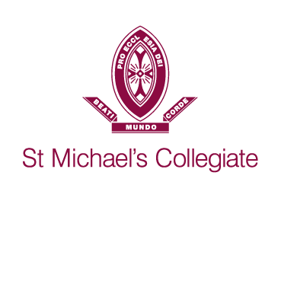
Meeting point
Basketball
Meeting point for Home and Away teams

Do not play if you feel unwell.

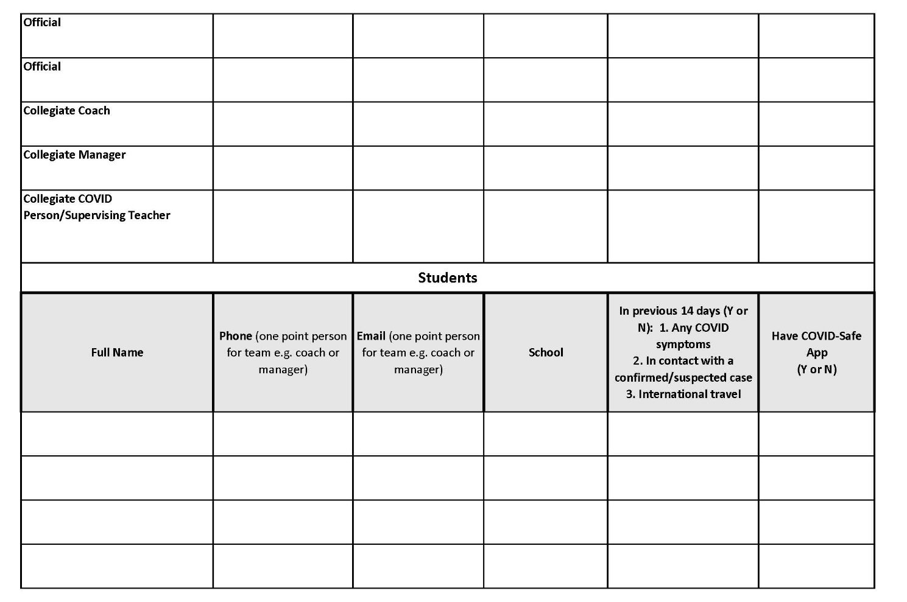
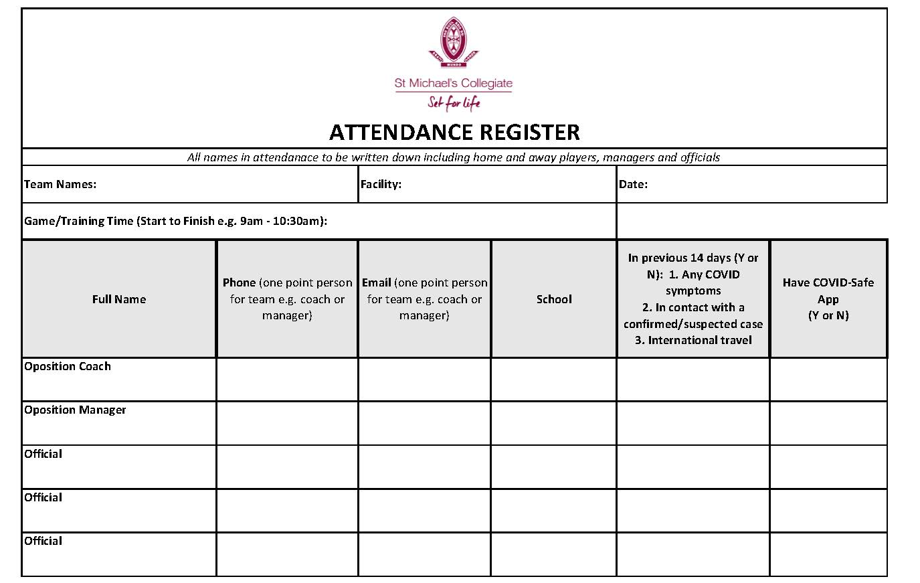
Appendix C

Appendix D

Staff Member Name: _________________________ Date: _______________
CHECKLIST
Procedures for using the Collegiate Gym

Hand sanitiser will be outside the Gym for staff and students to use. This will be checked by the PE staff.
Items to be checked | Tick
Managers/coaches to direct players/staff to wash their hands in the change rooms and hand sanitise before entering Gym.
No spectators allowed in Foyer or Gym (exception Pool parents)
Managers of both teams to complete the Attendance Sheet – including all officials – Manager of away team to give home manager their attendance
Manager to email photo or place attendance sheet in box inside sports admin office.
sport@collegiate.tas.edu.au

Equipment (balls) need to be wiped down before storing away. Cleaning equipment will be in the Gym.
Ensure people entering are to the best of their ability are aware of and abiding by COVID protocols.
Students and staff to enter using the foyer entrance and leave through the Exit door.
Turn off Lights and lock up Gym.

Thank you for taking these steps to make sure we all vigilant around being COVID safe.

