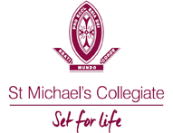

COVID-19 SAFETY PLAN – AFL
St Michael’s Collegiate

School | St Michaels Collegiate
School Location | 218 Macquarie Street, Hobart, 7000
Sport | AFL
Sport Facility Type and Location | Ham Common Sports Fields  Old Proctors Rd, Tolmans Hill, Tasmania
Principal | Dr Adam Forsyth
Contact Email | Adam.forsythe@collegiate.tas.edu.au
Contact Number | (03) 6211 4910
School COVID Officer for Sport | Jessica Blake
Contact Email | Jessica.blake@collegiate.tas.edu.au
Contact Mobile Number | 0431 105 862
Version | 2
Plan Last Updated | 02/07/2020
Plan Prepared by – Jessica Blake

Table of Contents
Template Instructions Error! Bookmark not defined.
1. Introduction Error! Bookmark not defined.
2. Key Principles Error! Bookmark not defined.
3. Responsibilities under this Plan Error! Bookmark not defined.
4. Return to Sport Arrangements Error! Bookmark not defined.
4.1 AIS Framework Arrangements 5
4.2 Roadmap to a COVIDSafe Australia 5
5. Recovery Error! Bookmark not defined.
Appendix: Outline of Return to Sport Arrangements 6
Part 1 – Sport Operations 6
SPORT: AFL 6
Part 2 – Facility Operations 8
FACILITY NAME: Ham Common Sports Fields 8
Type of Facility: Outdoor…………………………………………………………………………………………………………8
Appendix A - One Page Protocol Doc…………………………………………………………………………………………11
Appendix B - Attendance Register………………………………………………………………………………………………12
Appendix C - Pavilion Poster……………………………………………………………………………………………………13
Appendix D - Supervising Teacher Checklist…………………………………………………………………………………14
8

- Introduction
The purpose of this COVID-19 Safety Plan (Plan) is to provide an overarching plan for the implementation and management of procedures by St. Michael’s Colligate to support St. Michael’s Colligate and its members and participants in the resumption of SATIS sport.
The arrangements set out in this Plan are intended to prevent the transmission of COVID-19 among members, participants, coaches, officials, administrators/volunteers, visitors, families and the broader community. The Plan provides the framework to govern the general operation of the St. Michael’s Colligate any facilities it controls, the playing/training behaviour of all members and participants and the monitoring and reporting of the health of attendees at St. Michael’s Colligate facilities.
This Plan includes, but is not limited to, the conduct of:
  - staged training and competition activities (sport operations); and
  - facility management and supporting operations (facility operations).
At all times the Plan is subject to all regulations, guidelines and directions of government and public health authorities.
- Key Principles
This Plan is based on, and accepts, the AIS Framework for Rebooting Sport in a COVID-19 Environment (AIS Framework) and the National Principles for the Resumption of Sport and Recreation Activities (National Principles).
The Plan also accepts as key principles that:
- The health and safety of members, participants, coaches, officials, administrators/volunteers, visitors, families and the broader community is the number one priority;
- Members, participants, coaches, officials, administrators/volunteers, families and the broader community need to be engaged and briefed on St. Michael’s Collegiate return to sport plans;
- Facilities are assessed and appropriate plans are developed to accommodate upgraded hygiene protocols, physical distancing and other measures to mitigate the risk of transmission of COVID-19;
- Training cannot resume until the arrangements for sport operations and facility operations are finalised and approved, if necessary; and
- At every stage of the return to sport process St. Michael’s Collegiate must consider and apply all applicable State and Territory Government and local restrictions and regulations. St. Michael’s Collegiate needs to be prepared for any localised outbreak at our facilities, within our competitions or in the local community.

- Responsibilities under this Plan
St. Michael’s Collegiate retains the overall responsibility for the effective management and implementation of the return to sport activities and operations outlined in this Plan.
The Leadership team of St. Michael’s Collegiate is responsible for:
- Approving the Plan and overseeing the implementation of the arrangements in the Plan; and
- Revising the Plan as required, ensuring it reflects up to date information from government and public health officials.
The Leadership team of SMC has appointed the following person as the St. Michael’s Collegiate COVID-19 Safety Coordinator to execute the delivery of the Plan and to act as a point of contact for information relating to this Plan:
Name | Jessica Blake
Contact Email | sports@collegiate.tas.edu.au
Contact Number | (03) 6211 4918 or 0431 105 862
St. Michael’s Collegiate expects all members, participants, coaches, officials, administrative staff and volunteers to:
- Comply with the health directions of government and public health authorities as issued from time to time;
- Understand and act in accordance with this Plan as amended from time to time;
- Comply with any testing and precautionary measures implemented by St. Michael’s Collegiate;
- Act with honesty and integrity in regard to the state of their personal health and any potential symptoms; and
- Monitor their health and take a cautious approach to self-isolation and reporting of potential symptoms.
- Return to Sport Arrangements
As from 30 June, The Plan outlines specific sport requirements that St. Michael’s Collegiate will implement for Level C of the AIS Framework.
The Plan outlines specific sport requirements that St. Michael’s Collegiate will implement for Level B and Level C of the AIS Framework.
St. Michael’s Collegiate will transition to the training activity and facility use as outlined in Level B of the AIS Framework and the training/competition activities and facility use outlined in Level C of the AIS Framework when permitted under local restrictions and regulations.

  - AIS Framework Arrangements
The protocols for conducting sport operations and facility operations under Level B and Level C of the AIS Framework are set out in the Appendix.

  - Roadmap to a COVIDSafe Australia
St. Michael’s Collegiate will also comply with the Australian government’s Roadmap to a COVIDSafe Australia, which places limits on the type of activity that can be conducted and the number of people who can gather at facilities, notwithstanding the activities permitted by the AIS Framework (see below).

AIS Activities | Level A:  Training in no more than pairs. Physical distancing required. | Level B:  Indoor/outdoor activity. Training in small groups up to 10. Physical distancing required. |  | Level C:  Full sporting activity (training and competition) allowed. No restriction on numbers. Contact allowed.
Roadmap Activities | N/A | Step 1:  No indoor activity. Outdoor sport (up to 10 people) consistent with AIS Framework. | Step 2:  Indoor/outdoor sport up to 20 people. Physical distancing (deNotnsity 4m²). | Step 3:  Venues allowed to operate with up to 100 people with physical distancing. Community sport expansion to be considered consistent with AIS Framework. | Further steps  Be aware of Tasmanian state government updates on COVID protocols and apply these to the current safety plans. Now 500 people in outside areas.
- Recovery
When public health officials determine that the outbreak has ended in the local community, St. Michael’s Collegiate will consult with relevant authorities to identify criteria for scaling back its COVID-19 prevention actions. St. Michael’s Collegiate will also consider which protocols can remain to optimise good public and participant health.
At this time the Leadership Team of St. Michael’s Collegiate will consult with key stakeholders to review the delivery of its return to sport arrangements and use feedback to improve organisational plans and systems.

Appendix: Outline of Return to Sport Arrangements for start of Term 3 2020
Note – examples provided in this Appendix relate to Ham Common Sports Fields operations. Adjustments may be made for the return to sport arrangements of St. Michael’s Collegiate

Part 1 – Sport Operations
  - Sport: AFL
Area | Plan Requirements (for activities under AIS Framework Level B) | Plan Requirements (for activities under AIS Framework Level C)
Approvals | The school must obtain the following approvals to allow a return to training at Level B:  - State Government approval of the resumption of community sport.  - Relaxation of public gathering restrictions to enable training to occur.  - Local government/venue owner approval to training at venue, if required.  - National/state sporting body/local association approval of return to training for community sport.  - Club committee has approved return to training for club.  - Insurance arrangements confirmed to cover training. | The school must obtain the following approvals to allow a return to training/competition at Level C:  - Relaxation of public gathering restrictions to enable training to occur.  - Local government and St. Michael’s Collegiate (venue owner) given approval for training/competition at Ham Common  - National, state sporting body and SATIS approval to return to training/competition for community sport.  - SATIS committee has approved return to competition for St. Michael’s Collegiate.  - Insurance arrangements confirmed to cover competition.
Training Processes | - St. Michael’s Collegiate to emphasise AIS Framework principle of “Get in, train, get out” – arrive ready to train.  - Length and scheduling of training sessions to reduce overlap.  - Small group sessions, with no physical contact  - Personal hygiene enforced – hand sanitiser before and after play.  - All used equipment must be taken to designated bucket where it will be sanitised after each training/game;  - Players’ bibs must be placed in designated bucket where they will be washed after each training/game;  - No sharing of personal equipment.  - Students to take Collegiate Bus to Ham Common and will abide by school bus protocols  - Training attendance register kept by Manager and submitted to Sports department after each training. | - AIS Framework principles – full sporting activity that can be conducted in groups of any size (subject to COVIDSafe Roadmap) including full contact.  - Full contact under Level C guidelines is allowed;  - All used equipment must be taken to designated bucket where it will be sanitised after each training/game;  - Players’ bibs must be placed in designated bucket where they will be washed after each training/game;  - Personal hygiene enforced – hand sanitiser before and after play.  - Training/playing attendance register kept by Manager and submitted to Sports department after each training/game.  - All officials will be encouraged to download and activate COVID app.  - All umpires to use their own whistles;  - After training/games all players to wash before and after games at home.  - No sharing of food allowed – for example, no half-time oranges or lollies  - Changing rooms allowed on site with appropriate numbers outlined on the door of facility  - Players must come Ready to Train/Play  - Spectators to be reminded to keep physically distant and not to mingle in groups at any time around the oval.  - No mingling by players or spectators before or after training and games. Get In, Play, Get Out policy.
Personal health | - Graded return to sport to avoid injury.  - Advice to players, coaches, volunteers to not attend if unwell (including any signs/symptoms of cold, flu, COVID-19 or other illness).  - Each player to wash hands and use sanitiser before entering facility.  - Avoid physical greetings (i.e. hand shaking, high fives etc.).  - All players to use good hygiene if coughing or sneezing.  - Launder own training uniform and wash personal equipment  - No change rooms to be used on site  - Toilet facilities available for players and officials only  - No sharing of food at any time, players to bring own food and sanitise hands after eating.  - When using a mouthguard avoid taking it in and out. If touched must sanitise hands. | - Advice to players, coaches, volunteers to not attend if unwell (including any signs/symptoms of cold, flu, COVID-19 or other illness).  - Each player to wash hands and use sanitiser before entering facility.  - Each player to place bib in designated bucket after each training/game for cleaning.  - All players to use good hygiene if coughing or sneezing.  - All players to use their own water bottles – no sharing.  - Changing rooms allowed on site with appropriate numbers outlined on the door of facility  - No sharing of food at any time, players to bring own food and sanitise hands after eating.  - When using a mouthguard avoid taking it in and out. If touched must sanitise hands.
Hygiene | - Manager is responsible for spraying all benches used during training/games.  - Manager is responsible for ensuring supplies of hand sanitiser and sanitising sprays.  - Each team manager will have their ‘CLEANING KIT’ to use at visiting venues for hands and equipment.  - All officials to have their own whistles.  - No sharing of water bottles or use of bubblers.  - No spitting allowed  - Facility to be cleaned after each use | - Manager is responsible for spraying all benches used during training/games.  - Manager is responsible for ensuring supplies of hand sanitiser and sanitising sprays.  - Each team manager will have their ‘CLEANING KIT’ to use at visiting venues for hands and equipment.  - All officials to have their own whistles.  - No sharing of water bottles or use of bubblers.  - No spitting allowed  - Facility to be cleaned after each use
Communications | - St. Michael’s Collegiate will communicate summary of plan to all school players, visiting players, coaches, managers and officials.  - Signs at Ham Common will encourage players to sanitise before and after play.  - Signs at Ham Common to remind Spectators to keep physically distant  - Sign at Ham Common Pavilion for maximum number of players/officials allowed in Pavilion.  - All players – home and visitors – will be told to come Prepared to Training/Games. By Circular letters, emails and video.  - Use of School Circular letters, website, emails.  - Tutorials with Coaches and Managers with supporting video. | - St. Michael’s Collegiate will communicate summary of plan to all school players, visiting players, coaches, managers and officials.  - Signs at Ham Common will encourage players to sanitise before and after play.  - Signs at Ham Common to remind Spectators to keep physically distant  - Sign at Ham Common Pavilion for maximum number of players/officials allowed in Pavilion.  - All players – home and visitors – will be told to come Prepared to Training/Games. By Circular letters, emails and video.  - Use of School Circular letters, website, emails.  - Tutorials with Coaches and Managers with supporting video.

Part 2 – Facility Operations
  - Facility Name: Ham Common
  - Type of facility (indoor/outdoor): Outdoor
Area | Plan Requirements (for activities under AIS Framework Level B) | Plan Requirements (for activities under AIS Framework Level C)
Approvals | The School must obtain the following approvals to allow use of club facilities at Level B:  - State Government approval of the resumption of facility operations.  - Local government/venue owner approval to use of facility, if required.  - Club committee has approved plan for use of club facilities.  - Insurance arrangements confirmed to cover facility usage. | The Schol must obtain the following approvals to allow use of club facilities at Level C:  - State Government approval of the resumption of facility operations.  - Local government has given approval to use of facility, if required.  - Club committee has approved plan for use of club facilities.  - Insurance arrangements confirmed to cover facility usage.
Facilities | - Protocols exist for equipment and bibs with a SPORTS CLEANING INVENTORY checklist and sign off.  - A cleaning and sanitising STATION is provided with materials and equipment to sanitise equipment in the Pavilion.  - Each team will have their own ‘CLEANING KIT’ in addition to the one provided in the Pavilion to clean and sanitise kit and surfaces. This is the responsibility of the Manager. | - Protocols exist for equipment and bibs with a SPORTS CLEANING INVENTORY checklist and sign off.  - A cleaning and sanitising STATION is provided with materials and equipment to sanitise equipment in the Pavilion.  - Each team will have their own ‘CLEANING KIT’ in addition to the one provided in the Pavilion to clean and sanitise kit and surfaces. This is the responsibility of the Manager.
Facility access | Restrictions on facility access to limit anyone who has:  - COVID-19 or has been in direct contact with a known case of COVID-19 in the previous 14 days.  - Flu-like symptoms or who is a high health risk (e.g. due to age or pre-existing health conditions).  - Travelled internationally in the previous 14 days.  - Players will come READY TO TRAIN – BE READY, GET IN, TRAIN, GET OUT.  - Only players, coaches, managers and officials can enter Pavilion.  - Changing rooms facilities are NOT to be used except for toilet  - No mingling of players in groups before or after training  - No spectators  - All recommended to download and activate the COVID app.  - Maximum of 100 people at Ham Common with 1.5m Physical distancing of players and coaches during team talks.  - No shared food at the facility  - Detailed attendance register to be kept of players, coaches, managers and officials | - Players will come READY TO PLAY – BE READY, GET IN, PLAY, GET OUT.  - Only players, coaches, managers and officials can enter Pavilion.  - Changing rooms facilities for players only and must  - No mingling of players in groups before or after training/games.  - Spectators must be mindful of physical distancing whilst around the Oval.  - No mingling of Spectators.  - Spectators are advised to download and activate the COVID app.  - Maximum of 500 people at Ham Common with 1.5m Physical distancing of players and coaches during team talks and spectators on the sidelines.  - No shared food at the facility  - Detailed attendance register to be kept of players, coaches, managers and officials
Hygiene | - Cleaning of facility after games/trainings  - Manager is responsible for spraying all surfaces used during training.  - Manager is responsible for ensuring supplies of hand sanitiser and sanitising sprays.  - Each team manager will have their ‘CLEANING KIT’ to use at visiting venues for hands and equipment.  - No sharing of water bottles or use of bubblers.  - No spitting allowed  - No shared food  - Do not use bubbler  - Water bottles to be brought full and filled inside pavilion | - Cleaning of facility after games/trainings  - Manager is responsible for spraying all surfaces used during training.  - Manager is responsible for ensuring supplies of hand sanitiser and sanitising sprays.  - Each team manager will have their ‘CLEANING KIT’ to use at visiting venues for hands and equipment.  - No sharing of water bottles or use of bubblers.  - No spitting allowed  - No shared food  - Do not use bubbler  - Water bottles to be brought full and filled inside pavilion
Management of unwell participants | Any unwell player or official must not come to Ham Common.  A register of all players and officials will be kept and submitted to the sports administration team after each training and game.  - If a player or official does exhibit flu symptoms during training/game they will be asked to leave the Oval and wait in the Pavilion. Parents will be contacted to collect the player and the player will wait in the Pavilion until the parent/guardian arrives to collect them. | Any unwell player or official must not come to Ham Common.  A register of all players and officials will be kept and submitted to the sports administration team after each training and game.  - If a player or official does exhibit flu symptoms during training/game they will be asked to leave the Oval and wait in the Pavilion. Parents will be contacted to collect the player and the player will wait in the Pavilion until the parent/guardian arrives to collect them.
School responsibilities | The School will oversee:  - Provision and conduct of hygiene protocols as per the Plan.  - The capture of a record of attendance at all training and club activities and maintaining an up-to-date log of attendance.  - Coordination of Level B field and training operations.  - Operation of the school’s facilities in support of all Level B training activities in accordance with this Plan. | As per Level B.

Appendix A – Ham Common Facility Poster
AFL at Ham Common – Term 3
Collegiate COVID-19 Protocols
Do not come to sport if you are unwell

Arrive Ready, Get In, Play, Get Out
Players:
Arrive ready in your playing uniform.
Bring playing equipment, 2 x full drink bottle, personal medical items, mouth guard avoid taking it in and out during training/game and hand sanitiser.
Use the hand sanitiser provided when you arrive and after training/game.
No changing in the Pavilion or in the toilet area.
No mingling with players before or after training/games.

Arrive Ready, Get In, Play, Get Out

Parents/Spectators/Guardians
Comply with physical distancing requirements as you watch the game 1.5m apart.
Refrain from using the Pavilion and toilets.
Encouraged to download and activate the COVID SAFE app.

Arrive Ready, Get In, Play, Get Out

Coach/Manager
Take attendance and send photo of the sign-in sheet to Sports Administrator after every game and training session.
Ensure that all players have used hand sanitiser before and after each training/game.
Wash any bibs washed prior to all games and training.
Clean all footie balls and equipment used after the game/training. Cleaning materials and storage area for used and clean equipment is provided in the Pavilion.
Ensure no sharing of food by players (e.g. no half-time oranges or lollies).
If anyone is unwell, contact parent and ask player/official to sit in Pavilion until they can be collected.
Arrive Ready, Get In, Play, Get Out
*We request that you take reasonable measures to follow the above protocols. Failure to follow may result in further action being taken.*

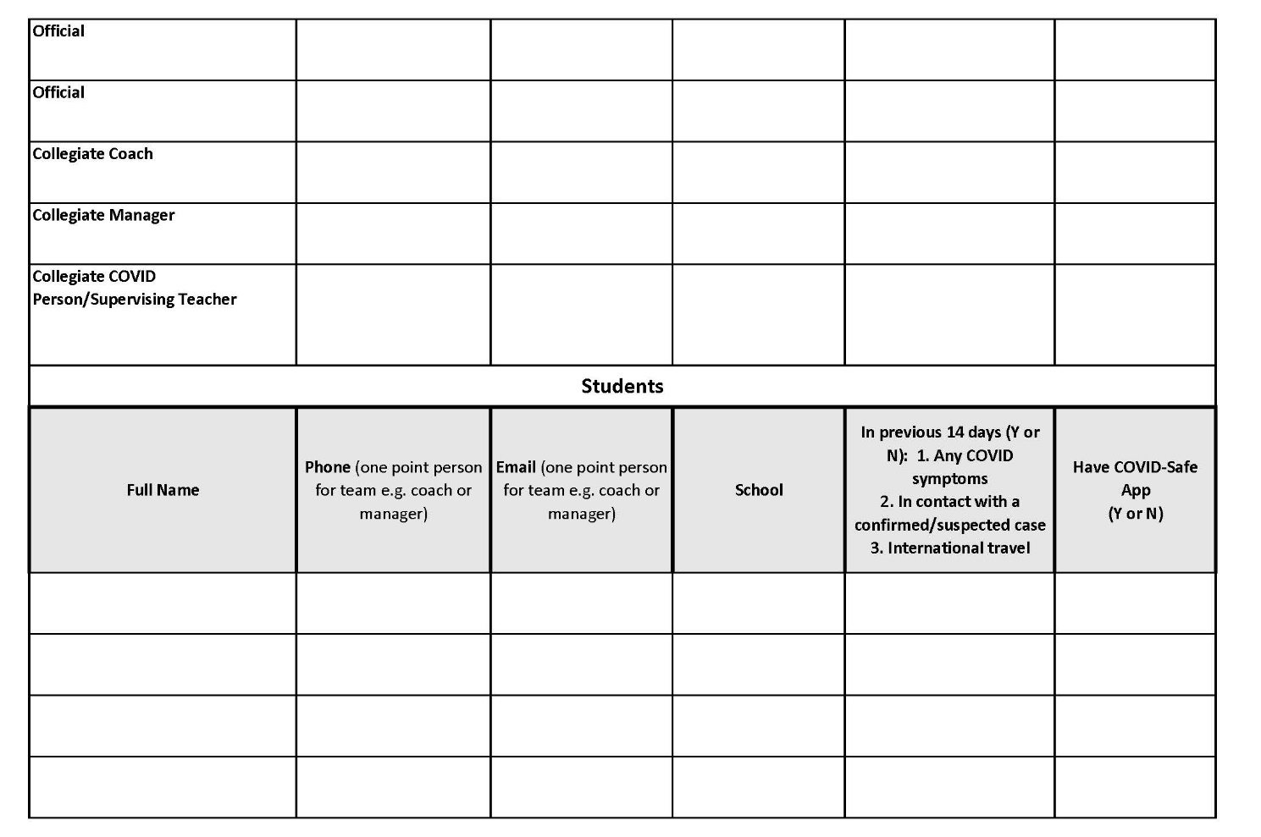
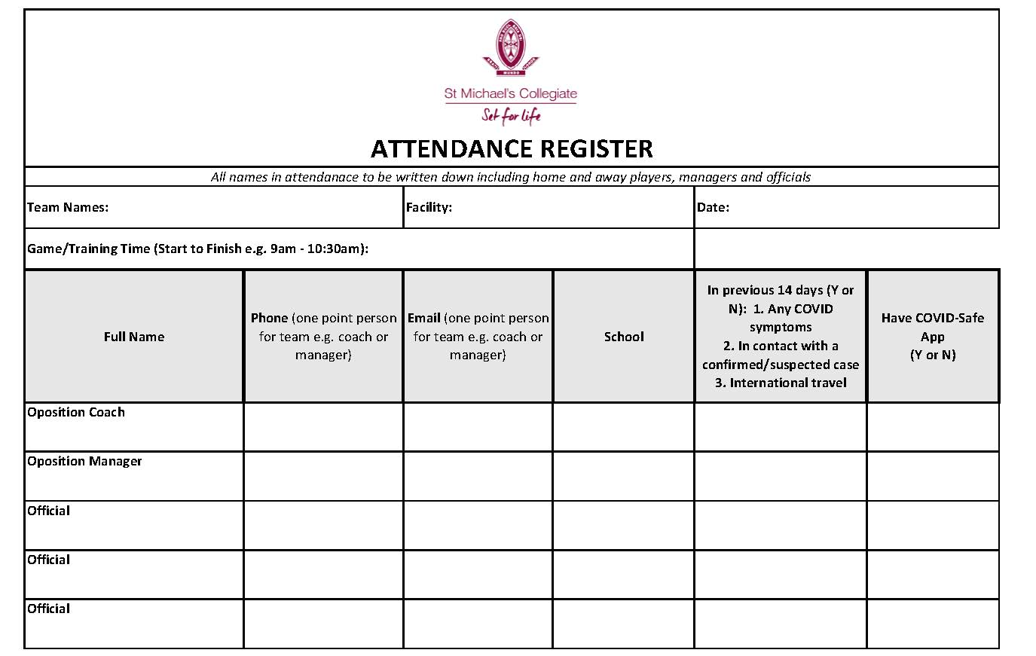
Appendix B – Attendance Register

Appendix C – Change Room/Pavilion Posters
TO HELP STOP THE SPREAD OF CORONAVIRUS, WE’VE MADE SOME TEMPORARY CHANGES TO THIS FACILITY
Thanks for your help!

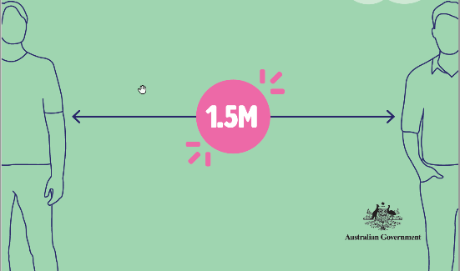

THIS AREA HAS A MAXIMUM NUMBER STUDENTS and OFFICIALS ALLOWED IN IT AT ANY ONE TIME:

Appendix D – Checklist for Supervising Teacher
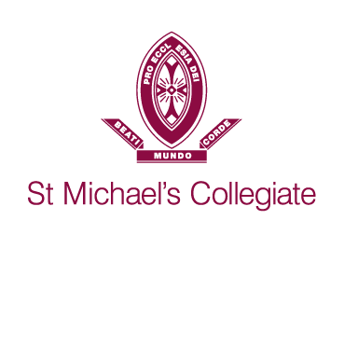

Staff Member Name: _________________________ Date: _______________
CHECKLIST
Procedures for using Ham Common Fields

Hand sanitiser will be at the gate and in coaches cleaning packs for staff, students and spectators to use. This will be checked by the Sports Admin staff.
Items to be checked | Tick
Managers/coaches to direct players/spectators to sanitise their hands prior to entry into the field.
Spectators to stay 1.5m apart while watching.
Spectators not allowed in pavilion.
Spectators may access toilets if needed.
Managers of both teams to complete the Attendance Sheet – including all officials – Manager of away team to give home manager their attendance register.
Manager to email photo of attendance of both teams including officials to;
sport@collegiate.tas.edu.au

Equipment (balls, bibs etc.) need to be wiped down before storing away. Cleaning pack given to team managers/coaches.
Ensure people entering are to the best of their ability are aware of and abiding by COVID protocols.
Turn off Lights and lock up Pavilion.

Thank you for taking these steps to make sure we all vigilant around being COVID safe.

